**Git/Vim Assignments**

**Assignment 1: (Complex)**

1. Commit a repository with a single file change.

Answer:

Create folder using “mkdir” command.

Initialize git using “git init” command.

Create a text file using “echo “hi” > file1.txt”

Add file to stage are using “git add” command.

Create first commit “git commit -m “first commit”.

To push to main

“git remote add origin https://github.com/adhithyamadhavan/gittutorial.git”

“git push -u origin main”.

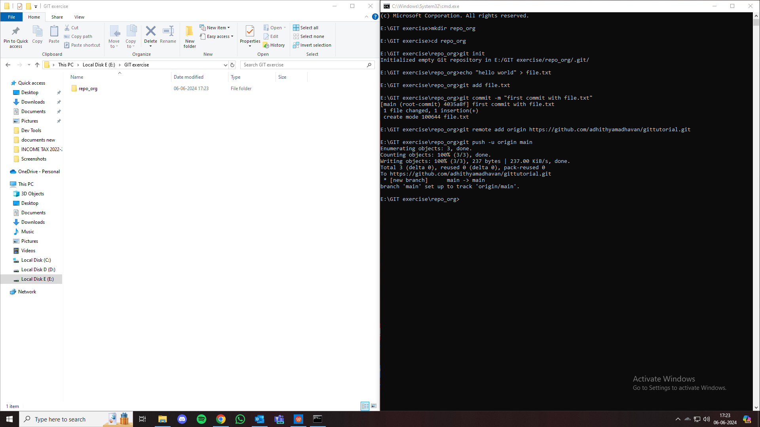

1. Create 2 new directories in local PC and clone the repository on both directories.

Answer:

To create new directory “mkdir clone1 clone2”

To clone repository in clone1 “git clone https://github.com/adhithyamadhavan/gittutorial.git clone1”

To clone repository in clone2 “git clone https://github.com/adhithyamadhavan/gittutorial.git clone2”

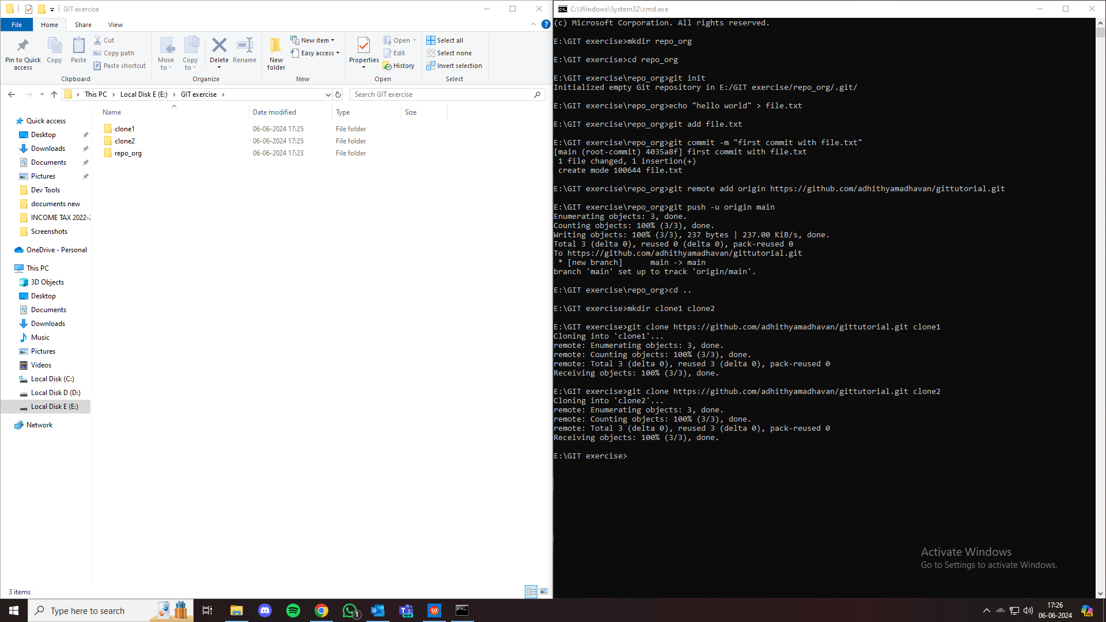

1. Make changes in one of the directories and commit and merge the changes.

Answer:

To navbigate to directory clone1 “cd clone1”

To make changes in clone1 “echo "Change in clone1" >> file.txt”

To add file to staging area and make commits “git add file.txt”

“git commit -m "Change made in clone1"

To push to main “git push origin main”

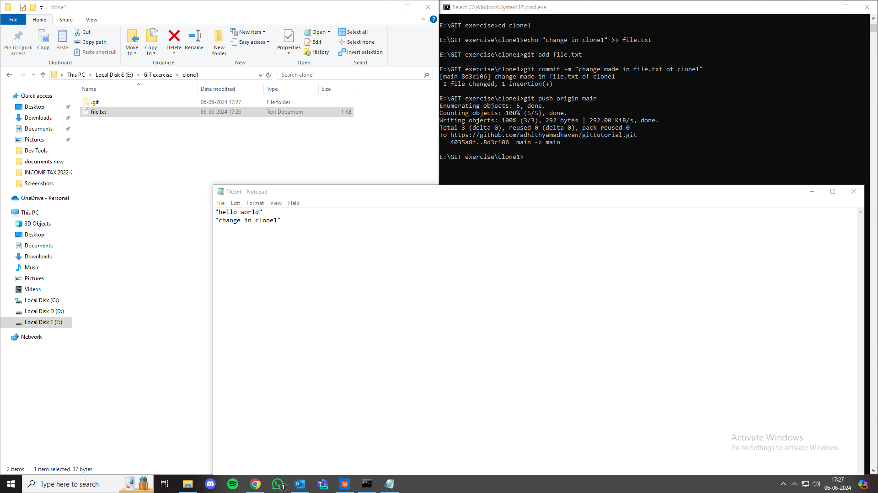

1. Parallelly make a change in the same file in another directory and when the changes are pushed, there should be merge conflict noticed which should be resolved and pushed changes again.

Answer:

Make changes in clone2 similarly.

When pushed creates merge conflict.

Use “git fetch origin” to fetch latest changes from repo.

Use “git merge origin/main” to merge changes

Resolve conflict manually and push again.

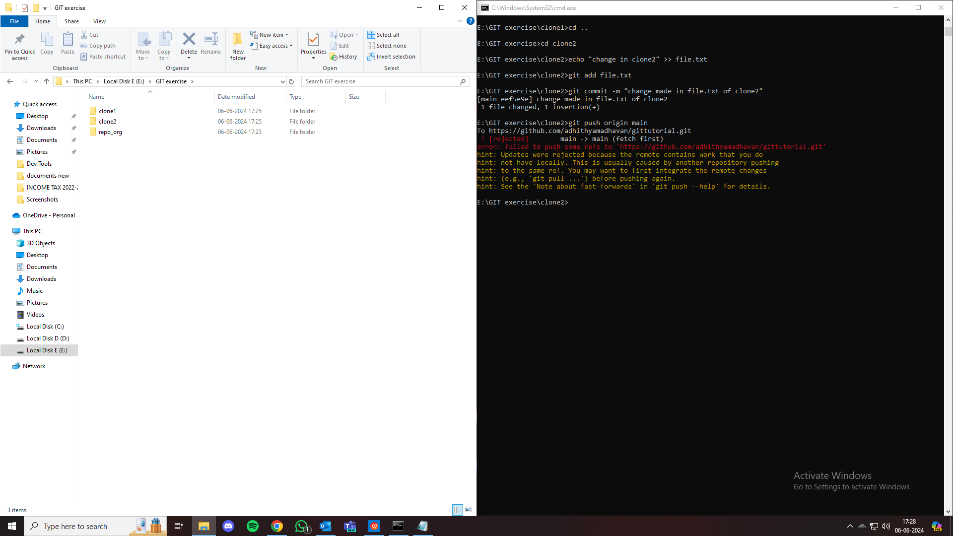

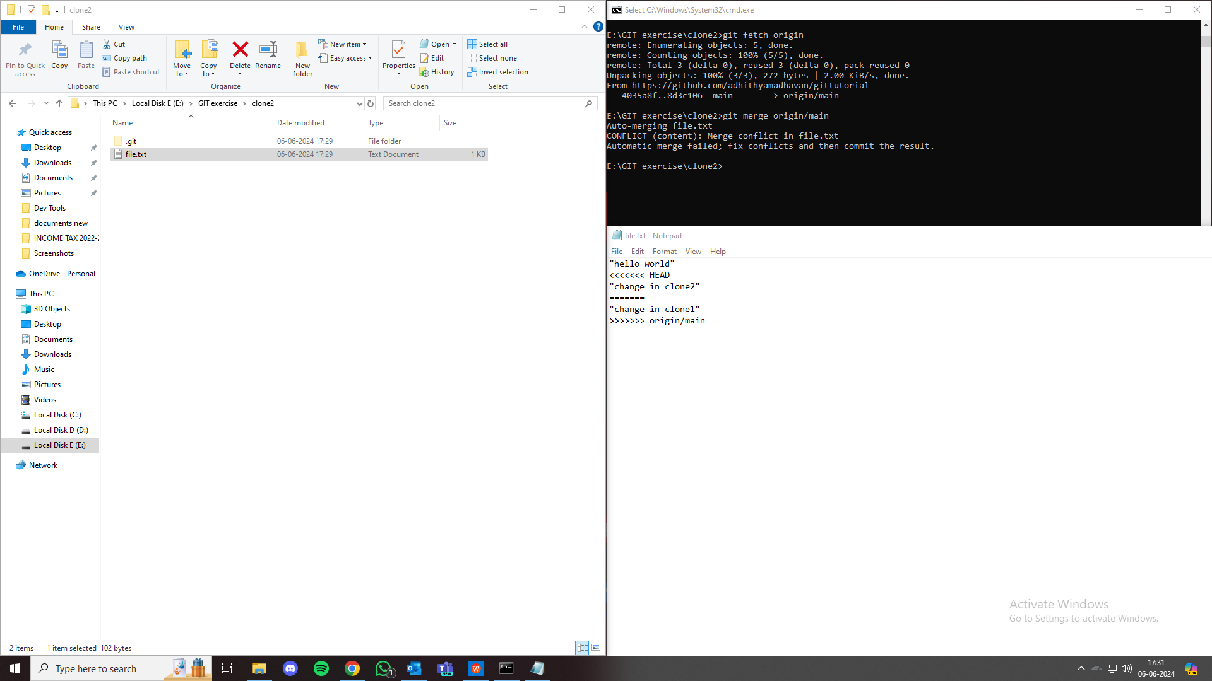

1. Merge the changes

Answer:

To merge changes,

Use “git pull origin main” in both clone1 and clone2 directories.

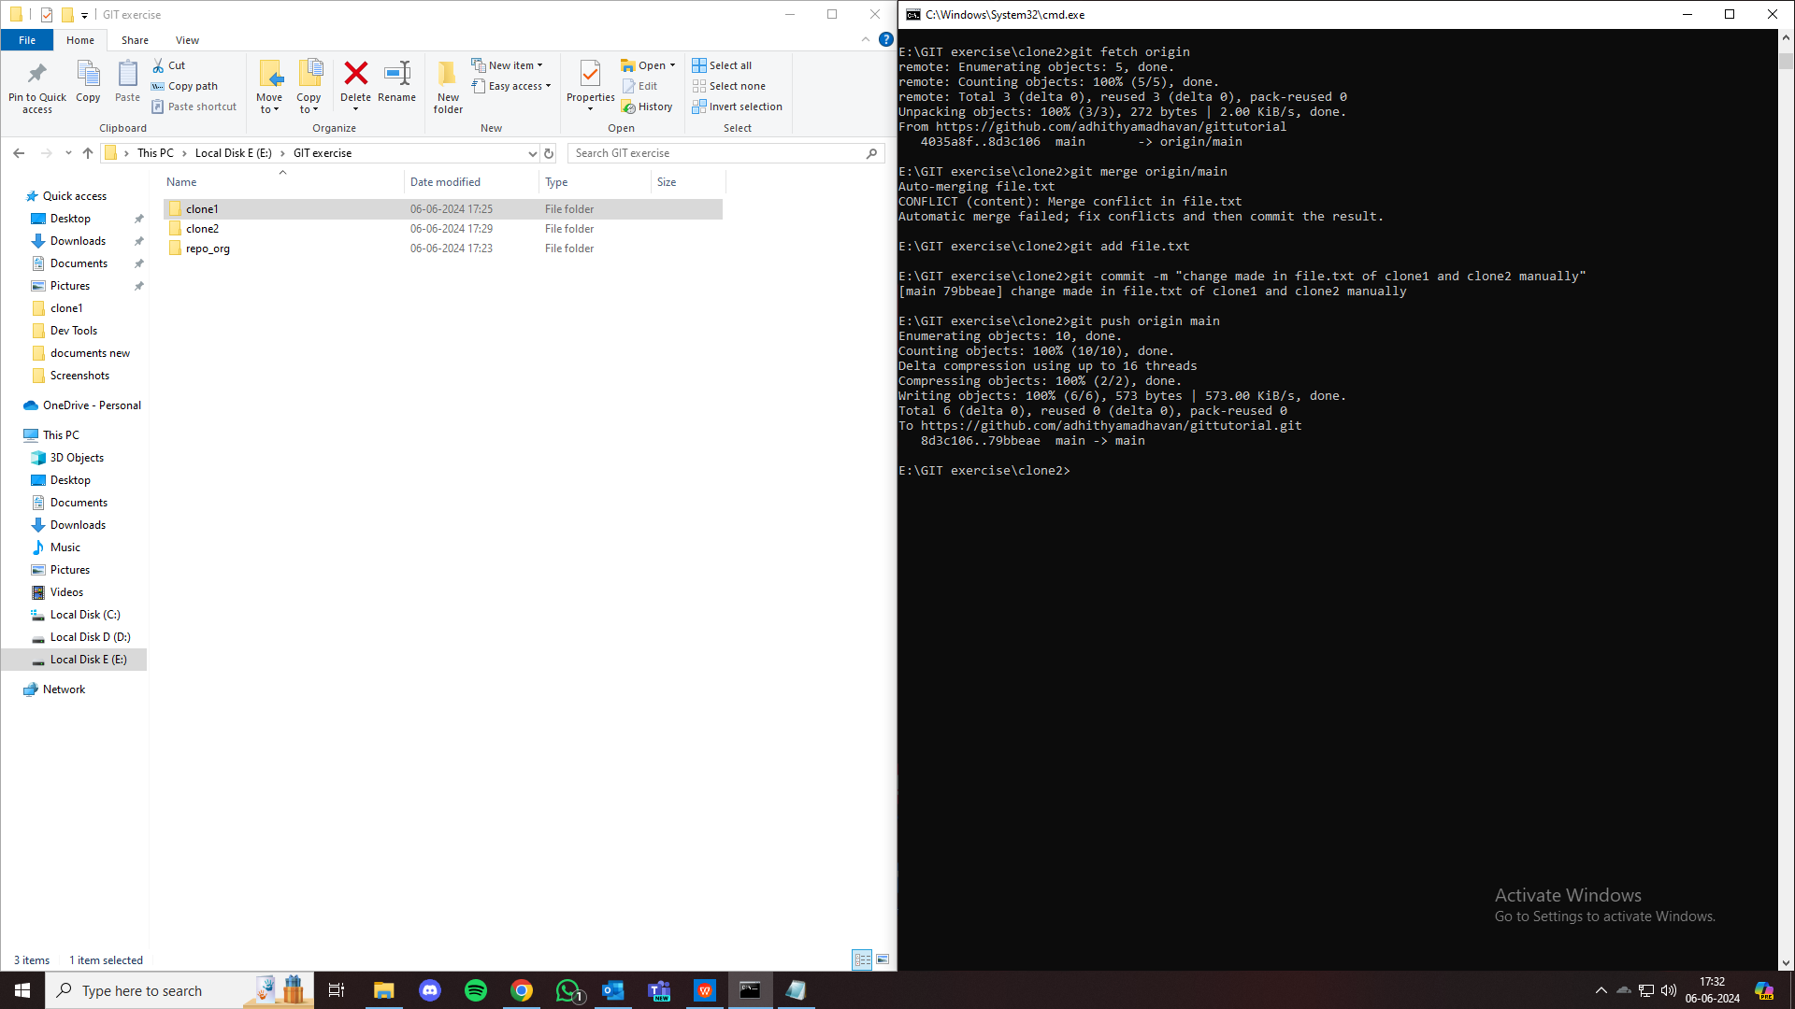

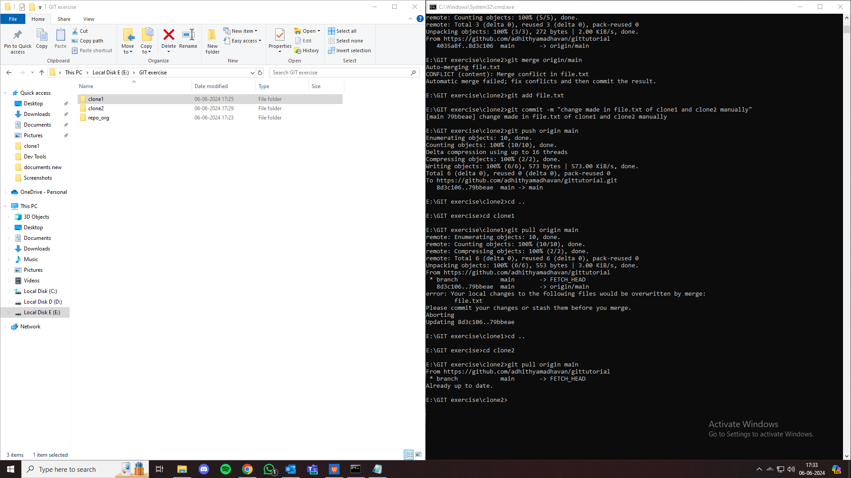

**Assignment 2: (Simple)**

Create a story.txt file using below lines, save and quit the file

To create story.txt,

In terminal type

Vim story.txt

Press “i” to initiate insert mode

Paste text

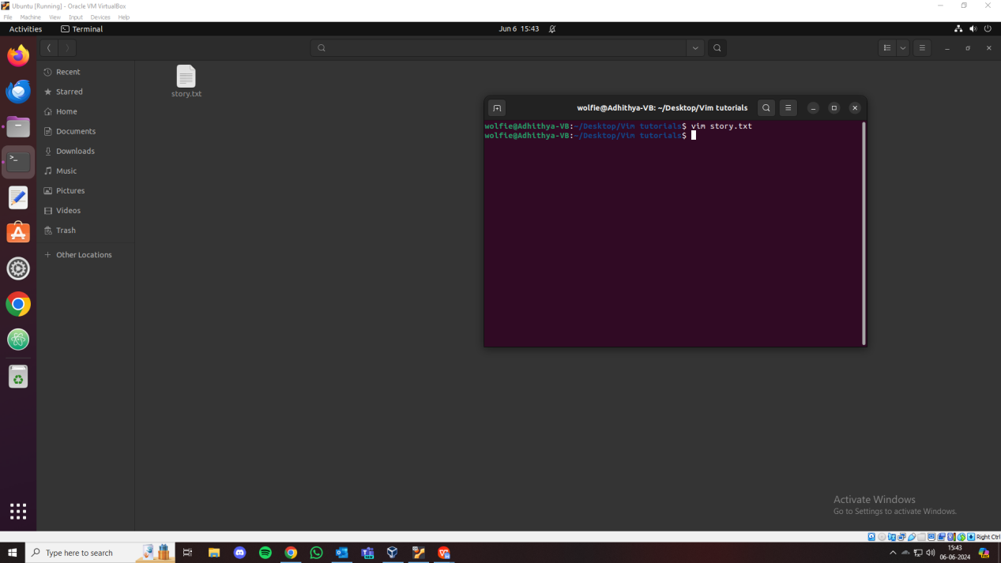

1. Replace fox with wolf, save and quit the file. Open and see if the changes gets reflected.

Answer :

To replace fox with wolf

Vim story.txt

Press “esc” or “:” to initiate normal mode

Type “%s/fox/wolf/g”

This will replace all occurences of the word “fox” with “Wolf”

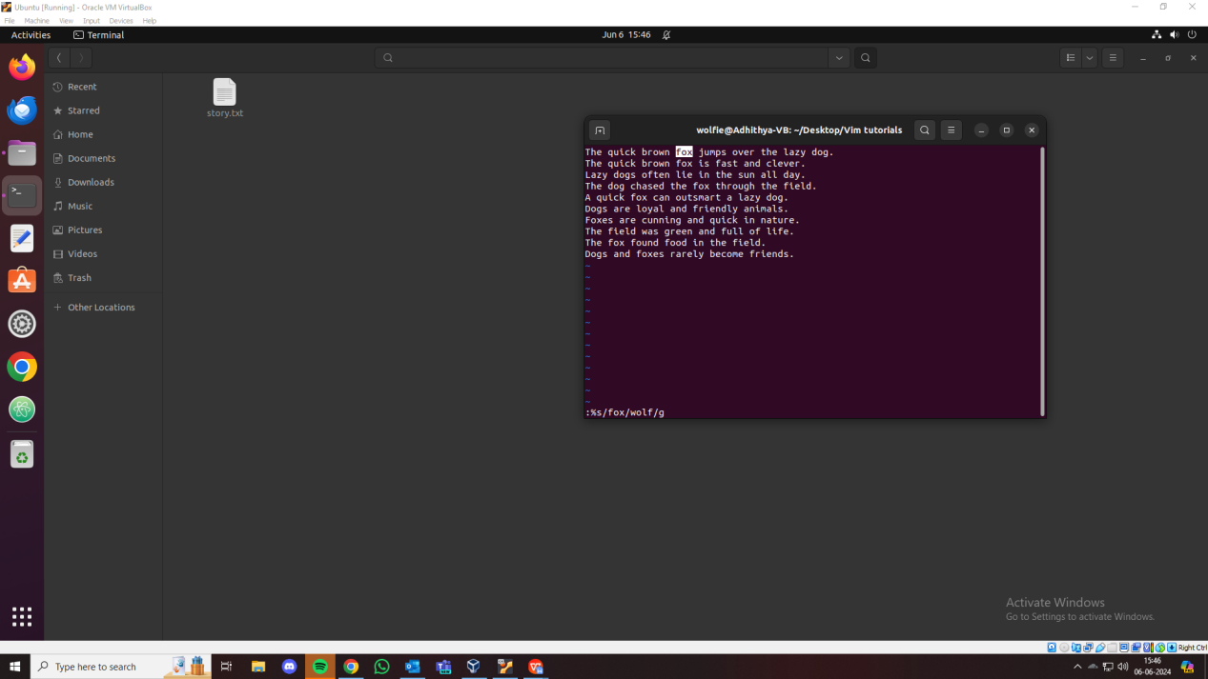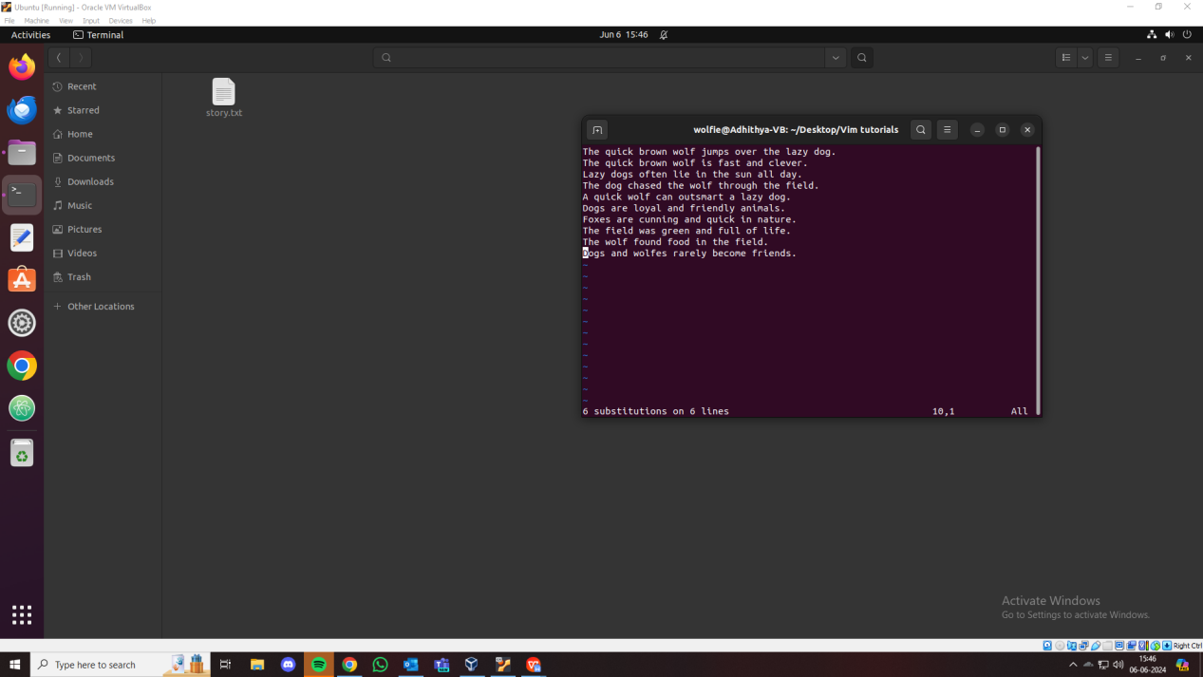

1. Search for string "field" in the file and move to next and prev occurence of the string.

Answer :

To search for string field

Vim story.txt

Press “esc” or “:” to initiate normal mode

Type “/field”

Press ‘n’ to find different occurences of the word field.

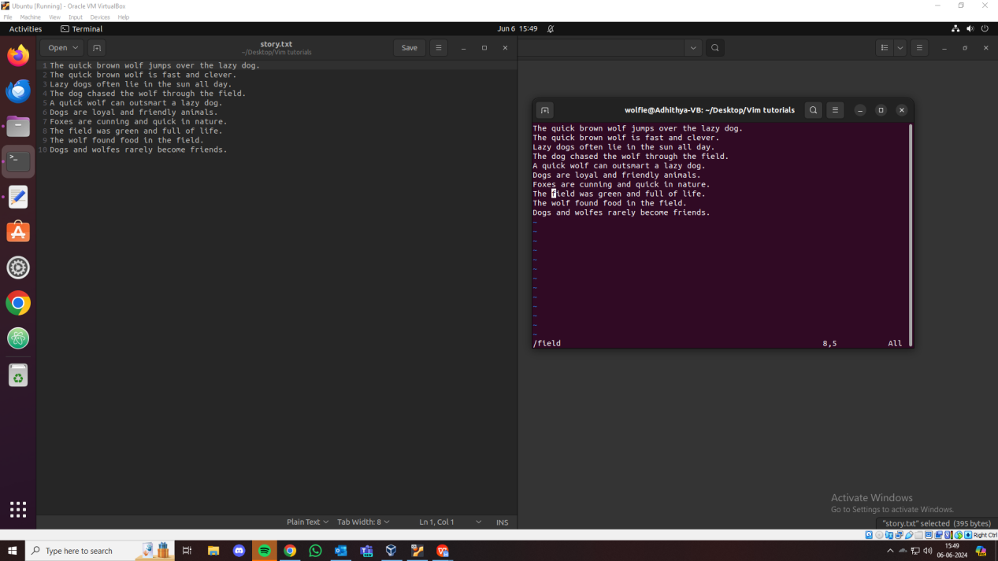

1. Copy the entire line "A quick fox can outsmart a lazy dog" and paste at the end of file and save it.

Answer :

To Copy the entire line "A quick fox can outsmart a lazy dog" and paste at the end of file and save it.

Vim story.txt

Press “esc” or “:” to initiate normal mode

Type “/A quick wolf can outsmart a lazy dog.”

Copy entire line using “yy’’.

Move to end of file using “G”.

Paste using “p”.

Quit and save using “:wq”.

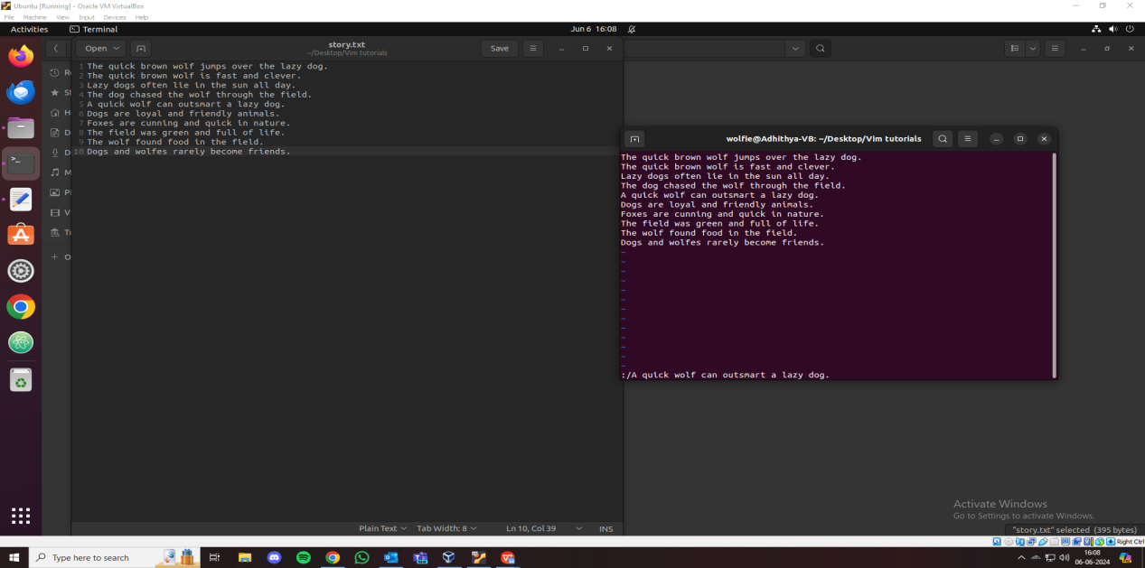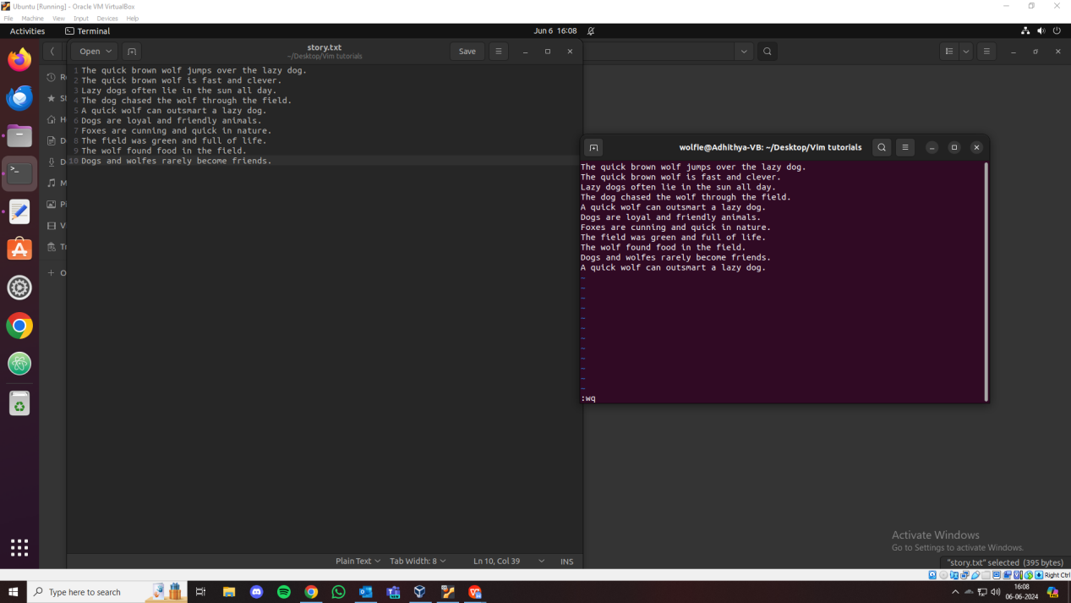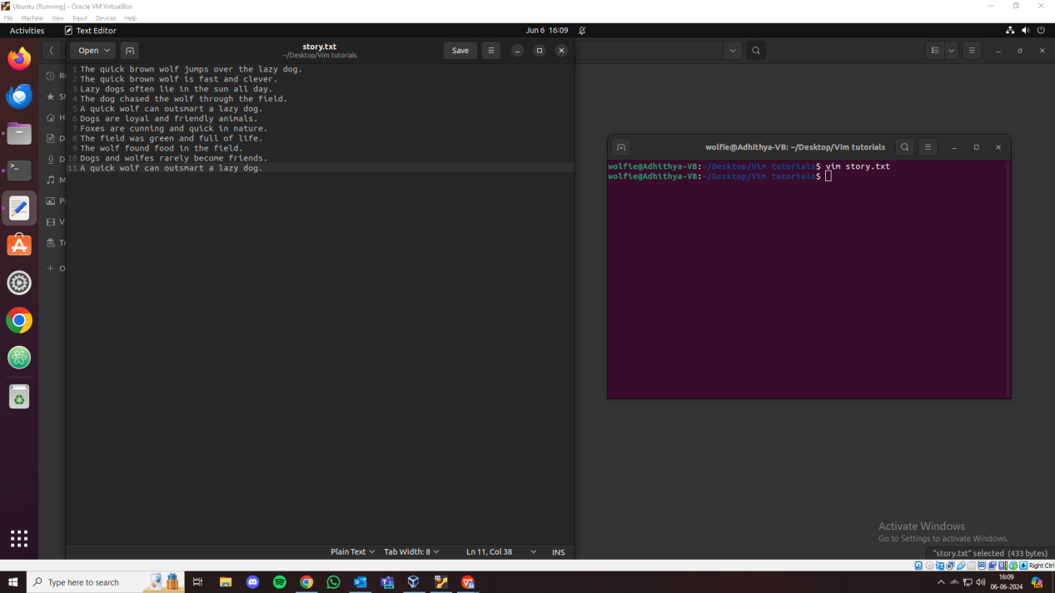

1. Replace all the vowels with letter "x" in the file.

Answer :

To Replace all the vowels with letter "x" in the file.

Type “%s/[aeiouAEIOU]/x/g”

Quit and save using “:wq”.

